Annual Family Orientation Weekend
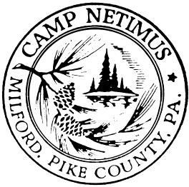
May 27-28, 2023

Bring the Whole Family!!!!

Family Orientation Weekend is an opportunity for new campers and their families to experience the magic of Camp Netimus.

The weekend schedule will include activities, workshops, meals, and lots of time to visit with staff, returning families, and Directors. We give families a feel for a “day in the life of Camp Netimus” - camp schedule, activities, meals, cabins, and campfires are modeled after a typical day at camp. We have informal question and answer sessions for parents and campers, both together and separately, so you can air your excitement, anxieties, and thoughts about the upcoming summer adventure. Every aspect of camp will be discussed - from arrival to departure.

Dates, Times & Accommodations

We’ll be holding our “Family Orientation Weekend” on May 27-28, 2023. Arrival time will be between 11:00-12:00 PM on Saturday, May 27th and departure time will be 3:00PM on Sunday May 28th. Cabin accommodations are first come, first served. Contact us promptly to reserve a cabin for you and your family.
Sleeping in a cabin not for you? Email us for a list of local accommodations OR just come for one day. During the week of May 22nd, we will email you the weekend schedule and packing list.

If you have any questions, please call us at 570-296-6131 or e-mail us at info@netimus.com. Brothers and other siblings are welcome.

We look forward to having you with us on Memorial Weekend!!
Tabz, Donna, and Arthi
REGISTRATION CONFIRMATION

Registration Deadline: May 1st

Arrival is between 11AM and 12PM on Saturday. Names of all participants and ages of children:

Address, City, State, Zip

Phone ( ) E-mail

Total number in party
# 13 and older ($55 PP) # 7-12 ($40 PP) # under 7(Free)
Total fee enclosed $

Accommodations at camp Saturday night? Yes or No (Circle one)

Limited availability, register early.

We will be attending the Family Orientation Weekend: fee does not change
Saturday only Sunday only Saturday & Sunday

Comments, concerns or late arrival conflict?

Mail to: Camp Netimus, 288 Nelson Rd, Sugar Run, PA 18846
Phone: 570-296-6131 E-mail: info@netimus.com

